Invitation to Tender

For the Supply & Delivery of Office Supplies including Paper Products & Print Consumables across the SSE & SGN estate

**Project Requirements Document**

Author: León Gómez

Date: 06/10/2020

Version: 1.1

**Contents**

**1.** **Introduction** 3

**1.1 SSE Plc 3**

**1.2 SGN 3**

**1.3 Our values** 3

**2.** **Contract Duration** 9

**3.** **Locations** 9

**4.** **The Project** 9

**4.1** **Introduction** 9

**4.2** **Background Information** 10

**5** **Detailed Requirements** 10

1. **Introduction**

**1.1 SSE Plc**

SSE’s core purpose is to provide the energy people need in a reliable and sustainable way.

Our strategy is about how we manage the external issues that influence energy provision; how we fulfil our core purpose of providing the energy people need; and how we achieve our principal financial objective of increasing annually the dividend payable to shareholders by at least RPI inflation.

**SSE at-a-glance**

* **30th largest company in the FTSE 100\***
* **£15bn market capitalisation**
* **Around 12,000 employees based across the UK and Ireland**
* **UK’s broadest based energy company**

Wholesale: producing, generating and trading electricity and gas;

Networks: transmitting and distributing electricity and gas

**Our Values**

Our SSE SET of values has been in place since 2006 and is the bedrock of

how we operate



**1.2 SGN**

We manage the network that distributes natural and green gas to 5.9 million homes and businesses across Scotland and the south of England. Whoever your supplier is, our pipes deliver gas safely, reliably and efficiently to every one of our customers. It's your gas, in our network. Our promises to our customers shape who we are. They ensure we employ the highest safety standards, strive for the best levels of service and put customers at the centre of everything we do. We also know we are expected to do our work in a way that causes minimum impact on our environment

**SGN at-a-glance** 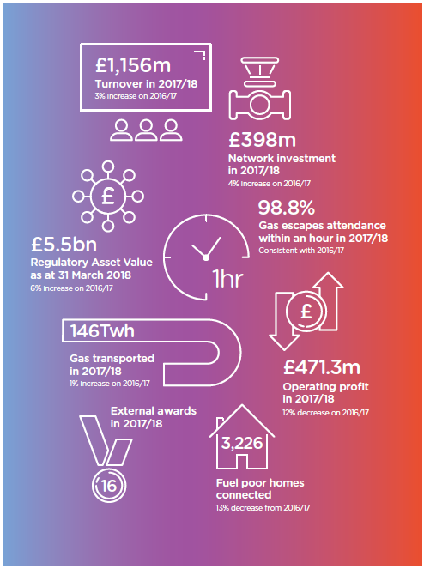

**SGN - The Future**

Intro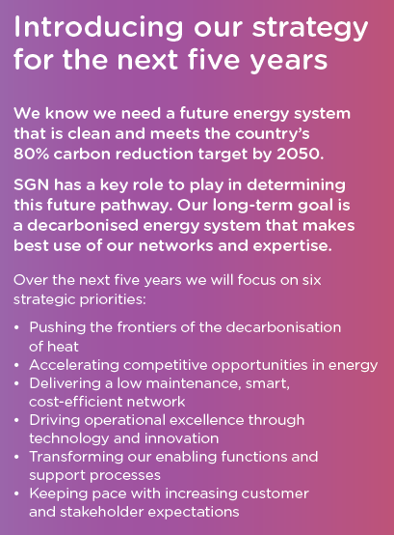 our strategy

for the next

We know we need a future energy system

that is clean and meets the country’s

80

**Our Values**

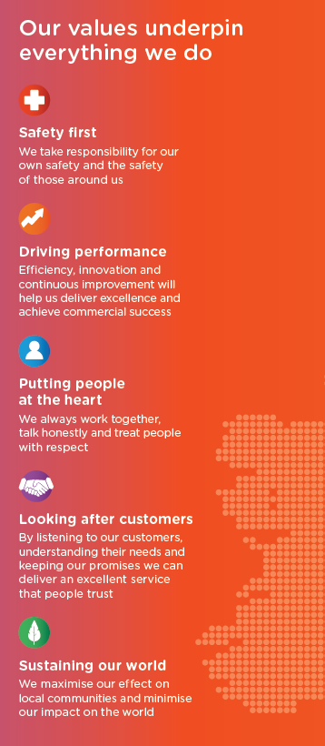

1. **Contract Duration**

This tender process will result in a Three (3) Year Contract with the option to extend for a further Two (2) years (to be reviewed after year 2) for the provision of these services.

1. **Locations**

UK wide.

1. **The Project**
   1. **Introduction**

SSE Services is proposing to place a contract for the Supply & Delivery of Office Supplies including Paper Products & Print Consumables across the SSE & SGN estate. The proposed form of contract will be SSE’s PD4 goods agreement and will include SSE required regulatory & SSE compliance clauses in line with SSE’s core values.

* 1. **Background Information**

Scope will include: The Purchaser requires that all Users within the company have access to secure online ordering facility for the purpose of “calling off” general office supplies and associated products as defined by a core list to be agreed and managed jointly between the Purchaser and the Supplier. In addition, further service provisions the supplier should be able to provide include but are not limited: management information & reports on usage, spend, etc, the ability to be able to support purchase cards assigned to specific Users and cost centres, provision & delivery of goods to various locations defined by SSE/SGN, adding or removal of items from agreed core lists. Itemised billing may be required on a business unit basis with Purchase order numbers to be logged on invoices as part of this process. Lastly, potentially support of the managed print service but this will be defined at a later stage. This particular area of service is to be managed by the chosen supplier(s) for all SSE and SGN sites with Office Supplies requirements in UK & Ireland.

1. **Detailed Requirements**

**5.1 Objectives**

The objectives of the ITT are to identify a list of suitable suppliers who can support. It is our intention to select a limited number of suppliers who will Supply & Deliver Office Supplies & the aforementioned associated services across the SSE and SGN estate in the UK.

SSE Services is proposing to place a contract for the Supply & Delivery of Office Supplies & the aforementioned associated services across the SSE & SGN estate. The proposed form of contract will be SSE’s PD4 goods agreement and will include SSE required regulatory & SSE compliance clauses in line with SSE’s core values. This requirement will be tendered as one Lot with potentially a separate contract for SGN. Contract duration will be 3 years with the option to extend for further 1-year periods up to an additional 2 years.

Scope will include but not limited to:

* Supply & Delivery of Office Supplies & associated services.
* Provision & delivery of goods to various locations defined by SSE/SGN
* Management information & reports on usage, spend, etc
* Support purchase cards assigned to specific Users and cost centres
* Adding or removal of items from agreed core lists
* Itemised billing may be required on a business unit by business unit basis with Purchase order numbers to be logged on invoices as part of this process
* Potentially support of the managed print service but this will be defined at a later stage